YUVA INTERNSHIP
Junior Data Analyst – Agribusiness
Task 3 : Supply Chain Analysis

INTRODUCTION

Tomatoes are a cornerstone of the global horticulture industry, valued for their versatility, nutritional content, and widespread culinary use. In India, they are cultivated across diverse agro-climatic zones, making them one of the most accessible and economically significant crops for both smallholder farmers and commercial producers. Their dual role—as a fresh produce item and a raw material for processed goods like sauces, purees, and canned products—positions tomatoes as a vital agribusiness commodity.
Despite their popularity and economic importance, tomatoes present unique challenges within the agricultural supply chain. Their high perishability, seasonal fluctuations, and sensitivity to handling and transportation conditions demand a well-coordinated and efficient supply chain. Any inefficiencies—whether in production, storage, transportation, or distribution—can lead to significant post-harvest losses, price instability, and reduced profitability for stakeholders.
This report aims to conduct a comprehensive analysis of the tomato supply chain, tracing its journey from farm to fork. By examining each stage—from cultivation and harvesting to processing, distribution, and retail—the report will identify key inefficiencies and bottlenecks that hinder optimal performance. It will also propose practical, scalable solutions to enhance supply chain efficiency, reduce waste, and improve outcomes for producers, distributors, and consumers alike.

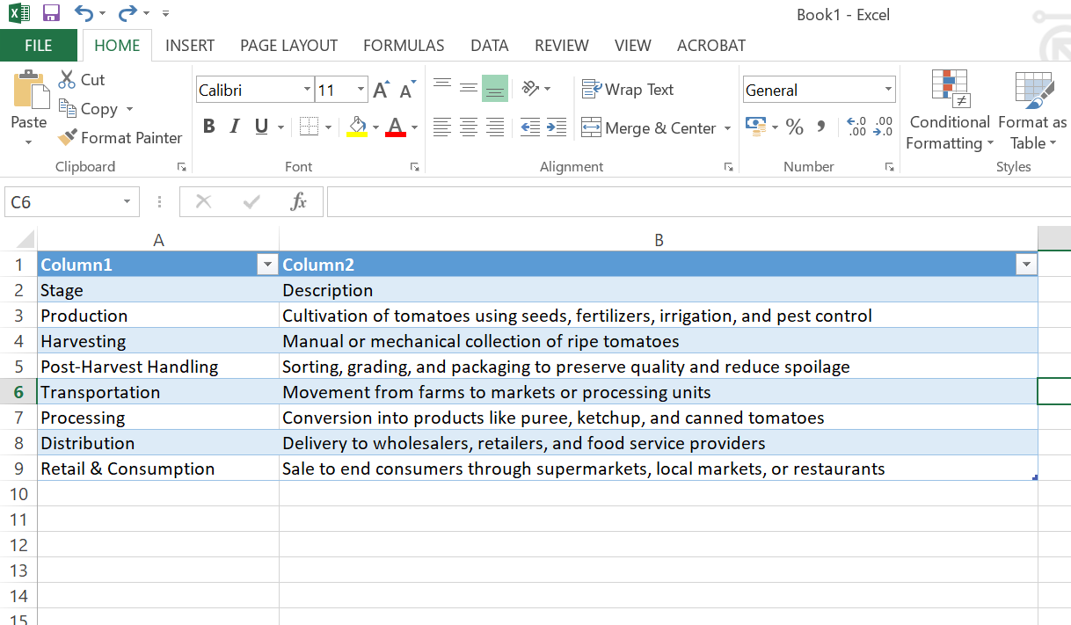

Efficiency Analysis of Each Stage

Production
Tomato cultivation is widespread across India, with farmers in regions like Andhra Pradesh, Karnataka, and Maharashtra relying on it as a primary source of income. The crop’s adaptability to various climates makes it a reliable choice for many, especially smallholder farmers. However, production is still heavily dependent on seasonal rainfall and traditional farming methods, which can limit yield and expose crops to pests and diseases.
Strengths
- Cultivated across diverse regions, ensuring year-round availability
- Flexible crop that adapts well to different soil and climate conditions
Challenges
- Vulnerability to erratic weather patterns and droughts
- Limited access to modern tools like soil sensors, automated irrigation, and disease diagnostics
Recommendations
- Promote precision farming using data-driven techniques to optimize water, fertilizer, and pesticide use
- Provide farmers with high-yield, disease-resistant seed varieties through government schemes and agri-tech startups
- Encourage community-based training programs to introduce sustainable farming practices

Harvesting
Harvesting tomatoes is a labor-intensive process, often done manually to avoid damaging the delicate fruit. While rural areas offer a steady labor supply, inconsistent harvesting practices can lead to premature picking, bruising, and reduced shelf life.
Strengths
- Availability of labor, especially during peak harvest seasons
- Manual harvesting allows for selective picking, preserving quality
Challenges
- Labor shortages during peak demand or migration seasons
- Lack of standardized harvesting techniques leads to uneven quality
Recommendations
- Introduce mechanized harvesting tools for larger farms to reduce dependency on manual labor
- Offer training workshops on optimal harvesting times and handling techniques to preserve fruit integrity
- Develop community harvest calendars to coordinate labor availability and reduce waste

Post-Harvest Handling
Post-harvest handling is a critical stage where much of the crop’s value can be lost. Without proper sorting, grading, and storage, tomatoes quickly deteriorate, leading to significant post-harvest losses—estimated to be as high as 30% in some regions.
Strengths
- Basic grading systems exist in local markets
- Growing awareness of quality standards among producers
Challenges
- Inadequate cold storage facilities, especially in rural areas
- Use of poor-quality packaging materials that cause bruising and spoilage
Recommendations
- Invest in cold storage units at village collection centers to extend shelf life
- Promote affordable, biodegradable packaging solutions that protect produce during transit
- Train farmers and vendors in post-harvest hygiene and handling protocols

Transportation
Transporting tomatoes from farms to markets or processing units is often fraught with delays, poor road conditions, and lack of refrigeration. These factors contribute to spoilage and reduce the market value of the produce.
Strengths
- Expanding road networks and logistics services
- Growing interest in agri-logistics startups offering farm-to-market solutions
Challenges
- Spoilage due to heat and rough handling during transit
- Lack of refrigerated vehicles for long-distance transport
Recommendations
- Deploy refrigerated trucks for bulk transport, especially for exports and urban markets
- Use GPS-enabled logistics platforms to optimize routes and reduce delivery times
- Encourage cluster-based transport models where farmers share logistics resources

Processing
Processing tomatoes into value-added products like puree, ketchup, and canned goods offers a way to reduce waste and increase profitability. However, small-scale farmers often lack access to processing units, and many regions have limited infrastructure for agro-processing.
Strengths
- Rising demand for processed tomato products in urban and export markets
- Presence of established brands and growing interest in local processing
Challenges
- High capital investment required for processing equipment
- Limited awareness of food safety and quality standards among small producers
Recommendations
- Establish cooperative-owned processing centers to serve multiple farming communities
- Provide government subsidies and low-interest loans for small-scale processing units
- Offer training in food safety, packaging, and branding to help farmers enter the processed goods market

Distribution and Retail
Tomatoes enjoy strong consumer demand, but the distribution network is often fragmented. Middlemen dominate the supply chain, reducing profits for farmers and contributing to price volatility. Retailers face challenges in maintaining freshness and managing inventory.
Strengths
- High consumer demand across fresh and processed segments
- Expanding retail channels including supermarkets, online platforms, and farmer markets
Challenges
- Price fluctuations due to market speculation and supply inconsistencies
- Limited access to direct-to-consumer sales models for small farmers
Recommendations
- Promote digital platforms that connect farmers directly with consumers and retailers
- Support local farmer markets and community-supported agriculture (CSA) programs
- Encourage e-commerce integration for small producers to expand their reach

Identified Bottlenecks

A comprehensive analysis of the tomato supply chain reveals several critical bottlenecks that hinder efficiency, reduce profitability, and contribute to significant post-harvest losses:
- Lack of Cold Chain Infrastructure Leading to Spoilage Tomatoes are highly perishable and require controlled temperature environments to maintain freshness. The absence of adequate cold storage facilities and refrigerated transport systems results in rapid spoilage, especially during peak summer months and long-distance distribution.

- Inefficient Transportation and Logistics Poor road connectivity, lack of route optimization, and delays in transit contribute to physical damage and quality degradation of tomatoes. Additionally, the absence of real-time tracking systems limits visibility and responsiveness across the supply chain.

- Limited Access to Processing Facilities for Smallholders Small-scale farmers often lack the infrastructure, capital, and technical support needed to process surplus tomatoes into value-added products. This leads to missed opportunities for income diversification and increased waste during peak harvest periods.

- Price Instability Due to Middlemen and Market Fluctuations The dominance of intermediaries in the supply chain reduces transparency and bargaining power for farmers. Prices fluctuate unpredictably, often leaving producers with minimal returns despite high consumer demand.

- Inadequate Training in Post-Harvest Handling and Storage Many farmers are unaware of best practices in sorting, grading, packaging, and storage. This lack of knowledge leads to improper handling, reduced shelf life, and lower market value of the produce.

Proposed Solutions
To address the above challenges and enhance the overall performance of the tomato supply chain, the following strategic interventions are recommended:

Infrastructure Development
- Cold Storage Units and Refrigerated Transport Establishing cold storage facilities at farm-gate and market levels, along with refrigerated vehicles for long-distance transport, will significantly reduce spoilage and maintain product quality.

- Rural Collection Centers Building decentralized collection hubs equipped with grading, sorting, and packaging infrastructure will streamline aggregation and improve market readiness, especially for smallholder farmers.

Digital Integration
- Mobile Applications for Direct Sales Developing user-friendly mobile platforms that connect farmers directly with consumers and retailers can eliminate middlemen, increase transparency, and improve profit margins.

- GPS and IoT for Supply Chain Tracking Implementing real-time tracking systems using GPS and IoT devices will optimize logistics, reduce delays, and enhance coordination across the supply chain.

Cooperative Models
- Farmer-Owned Cooperatives Encouraging the formation of cooperatives will enable shared ownership of processing and distribution infrastructure, allowing smallholders to access facilities and negotiate better prices.

- Collective Bargaining Mechanisms Cooperatives can leverage collective strength to reduce exploitation by intermediaries, stabilize prices, and ensure fair compensation for producers.

Capacity Building
- Training Programs on Modern Farming and Post-Harvest Practices Conducting regular workshops and field demonstrations will equip farmers with the knowledge and skills needed to improve productivity, reduce waste, and meet market standards.
- Access to Agricultural Extension Services Strengthening extension services will provide farmers with expert guidance, technical support, and continuous learning opportunities to adopt best practices across the supply chain.

Conclusion
The tomato supply chain in India is a cornerstone of the agricultural sector, providing employment to millions of smallholder farmers, laborers, and traders. It plays a vital role in ensuring food security, supporting rural economies, and meeting the nutritional needs of a growing population. Despite its significance, the supply chain faces persistent challenges that undermine its efficiency and sustainability.

Systemic Challenges and Their Impact
Infrastructural limitations—such as inadequate cold storage, poor road connectivity, and lack of processing units—lead to high post-harvest losses, estimated to be as much as 20–30% in some regions. Logistical inefficiencies, including delayed transportation and fragmented distribution networks, further exacerbate spoilage and reduce market competitiveness. Moreover, market imbalances caused by the dominance of middlemen and volatile pricing mechanisms leave farmers vulnerable to exploitation and income instability.
These systemic issues not only diminish the profitability of tomato cultivation but also discourage innovation and investment in the sector. Without strategic intervention, the supply chain risks stagnation, with long-term consequences for food availability, farmer welfare, and economic growth.

Strategic Interventions for Transformation
To unlock the full potential of the tomato supply chain, a multi-pronged approach is essential:
- Cold Chain Infrastructure Investment in temperature-controlled storage and transport will extend shelf life, reduce waste, and enable access to distant markets, including export opportunities.

- Digital Technologies Mobile platforms, e-marketplaces, and real-time tracking systems can democratize market access, improve transparency, and empower farmers with data-driven decision-making.

- Cooperative and Inclusive Models Farmer cooperatives and producer organizations can facilitate shared ownership of resources, collective bargaining, and equitable profit-sharing, fostering resilience and community empowerment.

- Capacity Building and Knowledge Transfer Training in post-harvest handling, quality standards, and sustainable farming practices will enhance productivity and ensure compliance with domestic and international market requirements.

Vision for a Sustainable Future
A reimagined tomato supply chain—built on innovation, inclusivity, and infrastructure—can serve as a model for other horticultural crops. By aligning public policy, private investment, and grassroots participation, stakeholders can create a robust ecosystem that delivers value across the entire supply chain.
This report outlines a strategic roadmap for transformation, urging policymakers, agritech innovators, NGOs, and farmer groups to collaborate in building a supply chain that is not only economically viable but also socially equitable and environmentally sustainable. With the right interventions, India can position itself as a global leader in tomato production and distribution, while uplifting millions of rural livelihoods in the process.

THANK YOU

